YCCTPP DOH Staff Contact List
Position | Name | Email | Phone
Community Wellness and Youth Education Manager | Steve Smothers | Steve.Smothers@doh.wa.gov | (360) 810-1817
Commercial Tobacco Prevention Manager | Heidi Glesmann | Heidi.Glesmann@doh.wa.gov | (564) 201-0034
Interim Community Partnership Manager | Me’Kyel Bailey | Mekyel.Bailey@doh.wa.gov | (360)-764-9161
Contracts Consultant | George Banks | George.Banks@doh.wa.gov | (360)-789-2401
Youth Commercial Tobacco Prevention Coordinator | Micah Zimmermaker | Micah.Zimmermaker@doh.wa.gov | (360) 790-8574
Youth Cannabis Prevention Coordinator | Mercedes Zahler | Mercedes.Zahler@doh.wa.gov | (564) 200-3946
Health Equity and Social Justice Coordinator | Katherine Zavala | Katherine.Zavala@doh.wa.gov | (360)-480-4689
Community Grants Coordinator | Liz Wilhelm | Liz.Wilhelm@doh.wa.gov | (360) 790-8026
Policy, System and Environmental Change Coordinator | Me’Kyel Bailey | Mekyel.Bailey@doh.wa.gov | (360)-764-9161
Commercial Tobacco Use and Dependence Treatment Consultant | Olivia Pineda | Olivia.Pineda@doh.wa.gov | (564)669-0657
Tobacco and Opioid Treatment Coordinator | Drew Paul | Drew.Paul@doh.wa.gov | (564) 669-1328
Research Investigator 3 | Sally Riggs | Sally.Riggs@doh.wa.gov | (360) 236-3264
Epidemiologist | Jordan Arias | Jordan.Arias@doh.wa.gov | (360) 790-0705
Communications Consultant | Carrie Gubsch | carrie.gubsch@doh.wa.gov | (564) 669-0516
Health Educator (Media) Cannabis | Nikki Meline | Nikki.Meline@doh.wa.gov | (360) 791-5807
Health Educator (Media) Commercial Tobacco | DeeSha Connor | DeeSha.Connor@doh.wa.gov | (360) 522-3469

YCCTPP Staff Overview
Title: Community Wellness and Youth Education Manager
Name: Steve Smothers
Role Overview:
Steve serves as leadership for the Community Wellness and Youth Education section, overseeing three programs including comprehensive cancer, oral health, and YCCTPP. He provides general leadership and support to the program as part of the Office Leadership Team.

Title: Commercial Tobacco Prevention Manager
Name: Heidi Glesmann
Role Overview:
Heidi serves as one of two co-managers for YCCTPP, overseeing all efforts related to the program. Her priority focuses include tobacco prevention and cessation efforts as the CDC’s National Tobacco Control Program (NTCP) Grant Manager for Washington, strategic planning, budgeting, program infrastructure and process improvement. She also serves as supervisor, providing leadership and support to all other team members of YCCTPP. She sits on multiple statewide coalitions and workgroups that focus on substance prevention and collaboration, including Washington Breathes, SPE, and Washington State Leadership Academy.

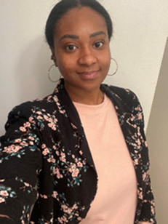 | Title: Interim Community Partnership Manager
 | Name: Me’Kyel Bailey
 | Role Overview:
 | Me’Kyel serves as one of two co-managers for YCCTPP, overseeing all efforts related to the program. Her priority focuses include cannabis prevention and implementation of community partnerships, including the launch of the community grants, in addition to policy, strategic planning, budgeting, and program infrastructure. She also serves as supervisor, providing leadership and support to all other team members of YCCTPP.

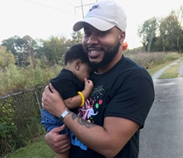 | Title: Contracts Consultant
 | Name: George Banks
 | Role Overview:
 | George oversees the contract and fiscal processes for YCCTPP through collaboration with the team’s contract managers and program managers. He works closely with internal agency fiscal and contracts team to ensure timely contract execution and payment. He provides ongoing technical assistance to the team and contractors for process improvement.

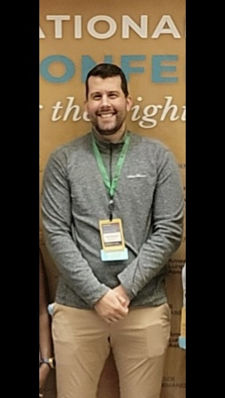 | Title: Youth Commercial Tobacco Prevention Coordinator
 | Name: Micah Zimmermaker
 | Role Overview:
 | Micah provides support to regional commercial tobacco contractors across the state. He is the contract manager and steering committee member of the Washington Breathes coalition. Micah also serves as a resource for smokefree housing questions.

Title: Youth Cannabis Prevention Coordinator
Name:
Role Overview:

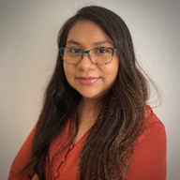 | Title: Health Equity and Social Justice Coordinator
 | Name: Katherine Zavala
 | Role Overview:
Katherine’s three main area of focus in her role are as follows:
Developing, administering, and managing commercial tobacco and cannabis prevention contracts with community-based and tribal-related organizations – Priority Population Contracts (30%)
Coordinates the planning and implementation of strategies, activities, and tactics to reduce commercial tobacco and cannabis-related disparities (30%) ​​
Planning and implementation of the DP20-2001 National and State Tobacco Control Program Communities-Based Disparities and Statewide Requirement (35%)

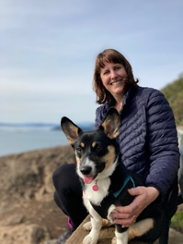 | Title: Community Grants Coordinator
 | Name: Liz Wilhelm
 | Role Overview:
 | Liz provides support to the new Community Based Prevention Capacity Building contracts (Community Grants, for short). Liz is also a director on the Prevention Specialist Certification Board (PSCBW) and serves as a resource for prevention science and prevention workforce questions.

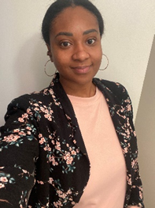 | Title: Policy, System and Environmental Change Coordinator
 | Name: Me’kyel Bailey
 | Role Overview:
 | Me’Kyel is key personnel doing legislative session, ensuring communication regarding legislative updates are provided to YCCTPP team and completion of bill analysis. She works to ensure intra- and interagency collaboration and coordination on policies related to commercial tobacco and cannabis. Additionally, she serves as a key technical assistance provider for contractors for policy, systems, and environmental change strategies.

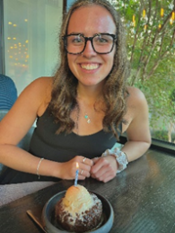 | Title: Commercial Tobacco Use and Dependence Treatment Consultant
 | Name: Olivia Pineda
 | Role Overview:
 | Olivia provides and supports the expansion of cessation services in Washington. She oversees all cessation contracting efforts, as well as the LCB compliance contract. Olivia is a member of the WA Breathes cessation workgroup, as well as a committee member of the education workgroup under the Washington Leadership Academy.

Title: Commercial Tobacco Use and Dependence Treatment Consultant
Name: Drew Paul
Role Overview:
Drew was recently hired at Washington State Department of Health, overlooking cessation efforts along with helping out other team members when needed. Drew is a member of the Washington Breathes cessation workgroup.

Title: Research Investigator 3
Name: Sally Riggs
Role Overview:
Sally assists YCCTPP with program evaluation and research projects. She currently serves as the program evaluator on the CDC DP20-2001 Commercial Tobacco Prevention Grant. In addition, she assists YCCTPP staff and with various aspects of evaluation, including survey design, survey administration and data analysis.

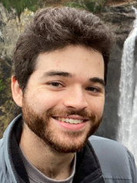 | Title: Epidemiologist
 | Name: Jordan Arias
 | Role Overview:
 | Jordan assists the Tobacco and Cannabis program with public facing data and data requests through data analysis, research of the literature, and creation of interpretable data products.

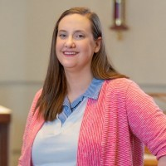 | Title: Communications Consultant
 | Name: Carrie Gubsch
 | Role Overview:
 | Carrie provides communications support to the youth cannabis and commercial tobacco team through communications planning and strategy. She writes web, organic social, press releases, blogs and more.

Title: Health Educator- Cannabis
Name: Nikki Meline
Role Overview:
Nikki works in the Executive Office of Public Affairs and Equity and serves as auxiliary staff to the YCCTPP. She oversees 8 contracts, including the tailored and statewide cannabis media contracts. There are 9 campaigns between these 8 contracts and Nikki oversees the development and implementation of these campaigns. She reviews media project proposals from partners, assists with social marketing projects across the agency, and sits on several state and national substance use prevention/education committees and coalitions.

Title: Health Educator-Tobacco
Name: DeeSha Connor
Role Overview:
DeeSha is a Health Educator in the Executive Office of Public Affairs and Equity and serves as auxiliary staff to the YCCTPP. She leads the statewide commercial tobacco prevention and cessation campaigns and reviews media requests from partners. In addition to media work, DeeSha works on other tobacco related assignments within DOH. She is a member of the communications work group in the WA Breathes Coalition.

